Travel Companion Functional Specification
CSE 403 – Software Engineering; Spring 2004
Last Updated: 3 May, 2004

Jordan Hom (jhom@cs)
Justin Quan (jq@cs)
Ben Higgins (bhiggins@cs)
Chris R. Baker (crbaker@cs)
Eric Kochhar (ekochhar@cs)
Abhinav Jain (jain0122@cs)

Abstract

Travel Companion (TC) is a web service that provides live-updating, location-aware directions to users. It also includes point of interest (POI) and commenting features. TC is divided into two components: a web site used to manage a user account settings, and a PocketPC application that uses the web service to provide TC’s features to a user on the go.

This specification is incomplete and will be reworked several times before it is finished. Any user interface graphics simply illustrate Travel Companion functionality. The actual user interface will be designed as the product evolves.

This specification only describes how users will interact with the Travel Companion; it does not describe how Travel Companion works. Such descriptions are in the architecture document.

Scenarios

Scenario 1: Local Travel
Bob is from Seattle. He doesn’t spend a lot of time downtown, but he’s going to take his girl there for a night she’ll remember. Normally he’s not very spontaneous; he usually plans his outings days in advance. However, tonight he’s going to leave it up to fate.

While taking a romantic stroll along the downtown waterfront he suddenly feels something vibrate in his pocket. It’s his PocketPC reminding him of his “buy-one-get-one-free” calamari dinner coupon for Red Robin. Bob had left himself a TC reminder for the coupon, and set it to appear whenever he was near a Red Robin. He dismisses this reminder, marking it as noted. Suddenly, Bob realizes this is a great opportunity to impress his girl! They go to Red Robin and have a wonderful dinner. Bob’s better half says he’s the best boyfriend in the world. Good thing he had his Travel Companion with him that night!

Scenario 2: Site Seeing
Matt has never been to the Bay Area, but he’s looking forward to seeing all the famous sites. Upon arriving in San Francisco, he decides to start his adventure. He pulls out his PocketPC and starts Travel Companion. Immediately it knows where he is, and it asks him where he wants to go. He chooses the Golden Gate Bridge from his list of points of interest. Travel Companion generates a set of directions for Matt to follow. On the way he is sidetracked and puts his PocketPC in, well, his pocket. After hours of wandering he remembers that he really wants to get to the Golden Gate Bridge to watch the sunset. He pulls out his PocketPC and sees that Travel Companion has correctly updated the directions based on his current location. After standing there for several moments, stunned at how amazingly cool this is, he embarks on the final stretch of his journey and makes it to the Golden Gate Bridge just as the sun begins to sink below the horizon. It is the most beautiful sunset Matt has ever seen.

Scenario 3: Visitor Information Center
Beth works at a visitor information center and is spearheading an initiative to improve the tourist experience in her city, Homville. She decides to use the Travel Companion service. Tourists will check out PocketPCs loaded with Travel Companion, and wander about Homville on their own, using TC as their virtual guide.

After signing up for the TC service via the web, she uploads possible points of interest (POIs) as tourist destinations not mentioned in the tour pamphlets. Along with the POIs she enters flattering descriptions of each location in the comments field. She then categorizes them into groups like landmarks, restaurants, and nightclubs.

In the following months tourists keep telling Beth about how much better their tourist experience has been, all because of Travel Companion! They love the extra points of interest that give the personal touch only a tour guide can provide, combined with the luxury of perusing the locations at their own pace. They say, “Travel Companion is totally sweeeeet! Homville rocks!” Beth is surely in line for a big promotion.

Non Goals

To prevent featuritis and to maintain focus during development, here is a list of what Travel Companion does not aim to do.

The PocketPC component is used primarily a consumer of the Travel Companion Web Service. It does not provide any form of account management.

The web site component is used primarily for account management. It does not provide any of the features of the handheld component.

The Travel Companion Web Service does not provide the following features:
- Location-aware friend tracking.
- Trip planning.
- Service on Smart phones, cell phones, or even laptops.
- Service on PocketPCs without the .NET Compact Framework.
- Service in areas lacking broadband wireless Internet access.
- Coverage in locations not supported by the Microsoft MapPoint Web Service.

Travel Companion Flow Chart

The following two diagrams are flow charts for the Web and mobile components of the Travel Companion service. The flow charts are by no means complete. However, they are sufficient for getting a feel for how each component works.

Both components display a series of screens to the user. Each screen tailors its interface about particular features, indicated by the flow char box names.

NOTE: Reminders are not standard screens. They are popup windows that may appear on top of the indicated screens when a reminder is triggered.

Mobile Component Flow Chart

Figure 1: Travel Companion - Mobile Component Flow Chart

Web Component Flow Chart

Figure 2: Travel Companion - Web Component Flow Chart

Screen by Screen Specification

Travel Companion’s mobile and web interfaces consist of several screens. Most screens on each component will try to follow a standard format to provide a consistent user experience. Any interface diagrams in this section do not represent the final Travel Companion look and feel. They are used to display functionality and user interactivity.

Mobile Component

Travel Companion’s Pocket PC component is split into several logical sections that provide distinct functionality to the user. Each screen is described below in terms of the features the each screen should provide.

Splash Screen
- Logo
- Authors / Developers
- Copyright
- Web services used (eg. Powered by Microsoft MapPoint)
- Skip Splash

Login
- Logo
- User name field
- Password field
- Submit information

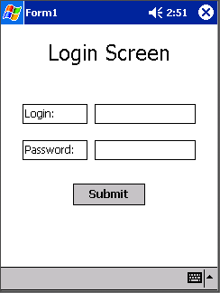
Figure 3: Handheld Login Screen (Mockup)

Configuration
- Default user / password
- Default screen
  - Map
  - Directions
  - POI
- Skip splash
- Server synchronization
  - Time between server synchronizations
- Reminders
  - Default reminder action
    - Dismiss
    - Defer
      - Time until next reminder
    - Delete
  - Distance to “marker” that triggers reminder (global to all)
  - Kind of reminder?
    - Sound
    - Popup

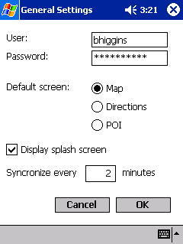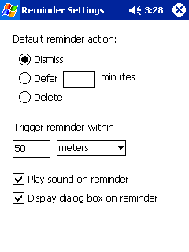
Figure 4: Handheld Preference Screens (Mockup)

Map
- Map
  - Zoom In/Out
  - Navigate
- Location markers
  - Eg. You Are Here. Destination Is Here.
  - POIs
    - Can choose POI categories shown
    - Selecting a POI brings user to POI screen
- Next few directions to destination
- Allow changing between different screens

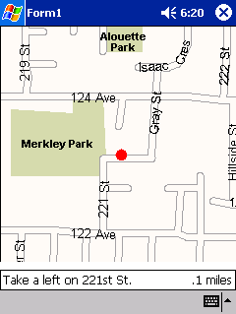
Figure 5: Map Display Screen (Mockup)

Directions
- List of directions
- Distance to next direction
- Overall distance from destination
- Update directions
- Get new directions/Change destination
  - Select from list of POIs
  - Enter standard street address
- Allow changing between different screens

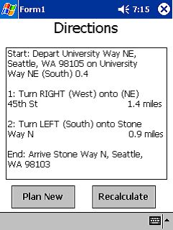
Figure 6: Directions Display Screen (Mockup)

Points of Interest
- Search/Filter fields
  - Name
  - Type
  - Distance
  - Friends
- Listing of POI
- Comments / Description of POI
- Get directions to selected POI
- Allow changing between different screens

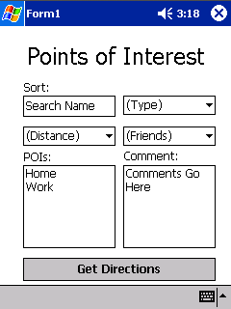
Figure 7: Point of Interest Display Screen (Mockup)

Reminders
- Popup floating windows
- User defined reminders
- Dismiss – mark as seen, do not remind again
- Defer – mark as seen, but remind later at some set period of time
- Delete – mark for deletion from server
  - Warn that deleting reminder will remove it from the server
  - Verify that user really wants to delete reminder

Web Component

Due to time constraints, mockup interfaces for the web component were not created. However, each screen is described below with list of features available to the user.

Sign Up / Log In
- Logo
- About information
- New users
  - Create new account
  - Set user name / password
- Existing users
  - User name field
  - Password field
- Submit information

Features List
- Travel Companion feature list
- Quick description of TC features
- Links to each page
  - Points of Interest
  - Reminders
  - Friends List
  - Profile

Points of Interest
- Current POIs
- Modify POI
  - Add
  - Remove
  - Edit
- POI Properties
  - Name
  - Type
  - Address, Apt, Street, City, State, Zip
  - Comments
  - Start / Expiration dates
- Access to other feature pages

Profile
- Email
- Home Address
- Access to other feature pages

Reminders
- Current reminders
- Modify Reminders
  - Add
  - Remove
  - Edit
- Reminder Properties
  - Address
    - Entered
    - Selected from POI
  - Reminder itself
  - Start/End time
- Access to other feature pages

Friends List
- Current friends
  - Add
  - Remove
- Friend’s public POIs
- Import friend’s POIs
- Access to other feature pages

